A
SEMINAR REPORT
on
Analog Engineering Internship at Texas Instruments, Bangalore

Submitted in partial fulfillment of the requirements for the award of degree of
BACHELOR OF TECHNOLOGY
in
ELECTRICAL ENGINEERING


Submitted By: Submitted To:
Aditya Kumar Jha Electrical Engineering
2022UEE1038 MNIT Jaipur
E2

DEPARTMENT OF ELECTRICAL ENGINEERING
MALAVIYA NATIONAL INSTITUTE OF TECHNOLOGY JAIPUR
September, 2025


MALAVIYA NATIONAL INSTITUTE OF TECHNOLOGY JAIPUR

CANDIDATE DECLARATION

I hereby submit the seminar report entitled “Analog Engineering Internship at Texas Instruments, Bangalore” in the Department of Electrical Engineering, Malaviya National Institute of Technology Jaipur.

 |  | Student Name: | Aditya Kumar Jha
 |  | Student ID: | 2022UEE1038

Date:

ACKNOWLEDGEMENTS
First and foremost, I extend my heartfelt thanks to Dr. Dipti Saxena for granting me this opportunity and for her constant encouragement. I am equally grateful to the Texas Instruments, Bangalore , especially Mr. Rohith Manohar (Validation team manager ) and Mr. Aniket Kumar (Analog engineer), for offering me this valuable internship opportunity. Their guidance, support, and encouragement throughout the process have been invaluable. Their expertise and insights have played a pivotal role in shaping the direction and quality of this work.
I would also like to express my sincere thanks to Ms. Priya Misra for coordinating the arrangements for my presentation, ensuring everything proceeded smoothly.
I also extend my gratitude to the Malaviya National Institute of Technology, Jaipur, for providing the necessary resources and a conducive environment to pursue this internship. I wish to acknowledge the contributions of my colleagues and peers, whose constructive feedback and engaging discussions enriched the quality of this report.
My heartfelt appreciation also goes to my friends and family for their unwavering support, patience, and understanding during the demanding period of report preparation.
Finally, I thank all individuals who, directly or indirectly, contributed to the successful completion of this project. Your efforts and collaboration are deeply appreciated and will always be remembered.

Thank you.

Date:
 |  | Student Name: | Aditya Kumar Jha
 |  | Student ID: | 2022UEE1038

ABSTRACT
This seminar report presents my experience of working on various EMC test methodologies for Analog IC at Texas Instruments. The increasing complexity and operating speeds of modern electronic systems have made electromagnetic compatibility (EMC) a critical design and validation concern. In high-speed data transmission applications, particularly in environments with strong electromagnetic interference (EMI), ensuring signal integrity and system reliability is essential. My internship work at Texas Instruments (TI) focused on the design and evaluation of a radiated immunity (RI) testing methodology based on IEC 61000-4 standards, with specific emphasis on IEC 61000-4-3, using optical–electrical (O/E) converters to enable robust data monitoring during EMI exposure.
The project involved developing a high-speed transmission system centered AFBR-2418MZ transmitter, and HFBR-1414MZ receiver. Each subsystem was powered by dedicated LDO regulators from a 12 V battery source to minimize noise coupling and maintain supply isolation. This modular architecture provided a controlled platform to evaluate propagation delay, and susceptibility to EMI under standardized conditions.
The RI testing methodology was structured around five key steps: isolated chamber setup with optical data links, field strength calibration, frequency sweep exposure (1GHz–6 GHz with steps of 100Mhz), real-time error monitoring, and performance classification according to IEC criteria (A–D). Optical–electrical converters were a central element of this approach, as they provided galvanic isolation and prevented external RF coupling from corrupting measurement paths.
Beyond RI testing, the work also emphasized the distinction between validation and testing of ICs. While validation involves deep lab characterization of analog performance metrics such as gain, PSRR, noise, and distortion, testing focuses on large-scale pass/fail screening at wafer and package level. Both are essential in ensuring reliable, manufacturable semiconductor products.
Overall, the internship provided hands-on experience in EMC test methodologies, high-speed data transmission systems, and IC validation practices. The proposed RI testing procedure contributes to TI’s efforts in building robust, EMI-resilient IC solutions, and the learnings gained will be valuable for future work in analog and mixed-signal system design.

LIST OF CONTENTS

S.No. | Content | Page No.
1. | Candidate Declaration  Acknowledgements  Abstract  List of Contents  List of Figures  List of Abbreviations | 2  3  4  5  6  7
2. | Internship Certificate | 8
3. | Introduction  3.1) About Texas Instruments  3.2) Description of task assigned during the internship  3.3) The purpose and expected outcomes of the internship project | 9
4. | Validation and Testing in IC design Flow  4.1) Analog circuit design Flow  4.2) EMC testing of ICs  4.3) Digital Isolators  4.4) IEC-61000-4 | 10-11
5. | Project Description and work done  5.1) Objective of project  5.2) Earlier testing procedure and drawbacks  5.3) Proposed testing procedure  5.4) Components used in new testing architecture  5.5) Test Setup Images | 19-25
6. | Challenges and Further Improvements  6.1) Challenges Faced  6.2) Benefits of the setup  6.3) Scope of Further Improvements in setup | 26-28
7. | Conclusion | 29

LIST OF FIGURES
S. No. | Name Of Figure | Page No.
1 | Flowchart of Analog IC design Flow | 12
2 | General setup for Radiated EMC testing | 13
3 | Galvanic/Capacitive Isolation | 15
4 | Optical Isolation | 15
5 | Magnetic Isolation | 15
6 | Edge based communication circuit | 15
7 | OOK based communication circuit | 16
8 | Block diagram of earlier testing procedure circuit | 19
9 | Block Diagram of new testing architecture | 20
10 | Signal Generator | 20
11 | O2E converter (AFBR-2418) | 21
12 | E2O converter (HFBR-1414) | 21
13 | Power Amplifier | 22
14 | Horn Antenna | 22
15 | Electromagnetic Field Probe | 23
16 | Oscilloscope | 23
17 | Setup outside the chamber | 23
18 | Setup inside the chamber | 24
19 | Block diagram of testing architecture with further improvements | 27

LIST OF ABBREVIATIONS
Abbreviation | Full form
RI | Radiated Immunity
DUT | Device Under Test
EMI | Electromagnetic Interference
IC | Integrated Circuit
E2O | Electrical to Optical Converter
O2E | Optical to Electrical Converter
LVDS | Low Voltage Differential Signalling
ASCII | American Standard Code for Information Interchange
Mbps | Megabits per second

INTERNSHIP CERTIFICATE


3)Introduction

- Name: Aditya Kumar Jha
- ID: 2022UEE1038
- Electrical Engineering
- Malaviya National Institute of Technology
- Period of Internship: 19.05.2025 – 18.07.2025
- Name of Co-ordinating officer & Head-BO: Mr. Aniket Kumar (Analog engineer), Mr. Rohith Manohar (Validation team manager)
3.1 About Texas Instruments
Texas Instruments (TI) is a global leader in the design and manufacturing of semiconductors and integrated circuits, headquartered in Dallas, Texas, USA. Founded in 1930, TI has played a pioneering role in advancing the electronics industry, being credited with inventions such as the integrated circuit and the handheld calculator. Today, the company focuses on developing analog and embedded processing products that form the backbone of modern electronics, enabling innovations across diverse sectors including automotive, industrial, personal electronics, and communications equipment. With a strong presence in more than 30 countries, TI delivers both standard and custom IC solutions that drive efficiency, performance, and reliability in cutting-edge applications.
TI’s mission is to create a better world by making electronics more affordable through its high-performance, energy-efficient semiconductor solutions. The company invests heavily in research and development, advanced process technologies, and robust manufacturing facilities to maintain leadership in analog and embedded markets. Beyond technical excellence, TI emphasizes long-term sustainability, employee growth, and customer-centric innovation. Its products are not only at the core of consumer devices but also crucial in emerging domains like renewable energy, smart infrastructure, and autonomous systems. This global impact and focus on innovation make TI an ideal environment for learning and contributing to real-world, industry-relevant projects.
3.2 Description of the tasks assigned during the internship
During my internship at Texas Instruments, I was assigned tasks focused on developing and validating a radiated immunity (RI) testing methodology for high-speed mixed-signal systems. This involved studying relevant IEC 61000-4 EMC standards, particularly IEC 61000-4-3, and setting up a transmission system based on the optical transceivers (AFBR series), LVDS receivers, and the THS3491 analog driver. I designed and implemented a test architecture powered through isolated battery–LDO supplies to minimize noise coupling, and integrated optical–electrical converters for isolated monitoring of transmitted data. My responsibilities further included generating pseudo-random bit sequences (PRBS) for testing, performing bit error and delay measurements under varying RF field strengths, and analyzing system behavior to classify immunity levels as per IEC-defined criteria.
3.3 The purpose and expected outcomes of the internship project
The purpose of the internship project was to evaluate the susceptibility of high-speed communication links to radiated RF fields and to propose a reliable RI testing methodology that could be adopted in IC validation practices at TI. By isolating the data monitoring path through optical–electrical converters, the project aimed to reduce measurement uncertainties and obtain accurate performance data under EMI exposure. The expected outcomes included identifying vulnerable system blocks, validating the effectiveness of optical isolation in immunity testing, and providing recommendations for design improvements in shielding, layout, and filtering. The project was also expected to contribute toward strengthening TI’s compliance evaluation methods, ensuring that future analog and mixed-signal IC solutions are robust, EMI-resilient, and reliable under real-world operating conditions.

4)Validation and Testing in IC design Flow

4.1 Analog circuit design Flow
The design of analog integrated circuits (ICs) is an iterative and methodical process that transforms a conceptual circuit idea into a manufacturable and reliable silicon product. The flow begins with the identification of a suitable circuit topology and the specification of design constraints, which typically include parameters such as gain, bandwidth, power consumption, noise, output swing, supply voltage, and silicon area. These constraints are influenced not only by the target application but also by technology limitations and customer requirements. Once the topology and constraints are defined, designers explore the design space through circuit sizing, bias point selection, and trade-off analysis. This step is often aided by optimization algorithms and EDA tools that help achieve a balance between conflicting objectives such as speed versus power or gain versus linearity.
Following initial sizing, the circuit undergoes detailed performance evaluation using SPICE-based simulations. This stage provides insight into small-signal and large-signal behavior, transient response, noise characteristics, and frequency-domain performance. If the specifications are not satisfied, the design loops back for resizing or even reconsideration of the topology. When the performance meets initial targets, the design moves into variability analysis and yield estimation. This step evaluates the robustness of the circuit under process variations, voltage fluctuations, and temperature changes through corner analysis and Monte Carlo simulations. Yield estimation is critical because even if a circuit meets specs nominally, excessive sensitivity to variations can lead to poor manufacturability and economic loss. If the yield is insufficient, corrective adjustments are made to device sizing, biasing, or topology.
Once variability and yield requirements are met, the circuit is translated into its physical form through layout design. During this stage, geometrical placement and routing introduce parasitic resistances, capacitances, and couplings, which can degrade circuit performance. Parasitic extraction is therefore performed, generating a more accurate netlist that includes these effects. The extracted netlist is re-simulated for post-layout performance evaluation, ensuring that the circuit still meets the original specifications under realistic physical conditions. If significant degradation occurs, the flow loops back to either layout modifications or design resizing. This cycle continues until post-layout verification confirms specification compliance.
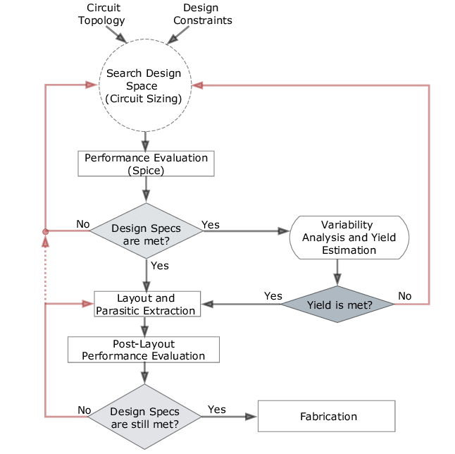
After validation through simulations and post-layout checks, the design is finalized and prepared for tape-out, which marks the transition to fabrication. Once the silicon wafers are manufactured, the fabricated ICs undergo rigorous testing to verify their functionality, performance, and reliability in actual hardware. Testing involves electrical characterization, corner validation, accelerated stress testing, and compliance checks with industry standards such as EMC and ESD. Here, validation ensures before fabrication that the design concept is robust, correct, and manufacturable, while testing after fabrication ensures that the produced ICs conform to their specifications, are free of manufacturing defects, and meet reliability expectations. Together, validation and testing form a continuous feedback loop in the analog IC design flow, reducing costly design re-spins, ensuring high production yield, and guaranteeing that end customers receive high-performance, EMI-resilient, and reliable semiconductor solutions.
Fig. 1: Flowchart of Analog IC design Flow

4.2 EMC testing of ICs
Electromagnetic Compatibility (EMC) testing of integrated circuits (ICs) is a critical step in ensuring that semiconductor devices can operate reliably in real-world environments without being adversely affected by electromagnetic interference (EMI) or themselves becoming sources of unwanted emissions. As ICs are deployed in increasingly complex and noise-sensitive systems such as automotive electronics, industrial automation, medical equipment, and high-speed communication devices, their immunity to external disturbances and compliance with EMC regulations become essential for both safety and functionality. The purpose of EMC testing is twofold: to verify that an IC does not emit electromagnetic disturbances beyond allowable limits (emissions testing) and to ensure that it can tolerate and function correctly in the presence of external electromagnetic fields (immunity testing). Standards such as the IEC 61000-4 series and ISO 11452 define rigorous test methodologies for radiated and conducted disturbances that ICs must undergo during validation.
In practice, EMC testing of ICs involves several key procedures. Emission testing evaluates the noise radiated or conducted by the IC during operation, typically using spectrum analyzers and specialized test setups like GTEM cells, TEM cells, or anechoic chambers to measure radiated signals over a wide frequency range. Excessive emissions can cause malfunction in nearby sensitive devices, so compliance with emission limits ensures system-level harmony. Immunity testing, on the other hand, subjects the IC to controlled electromagnetic fields or injected disturbances to evaluate its susceptibility. Radiated immunity tests, such as those defined by IEC 61000-4-3, expose the IC to RF fields across a range of frequencies (80 MHz to 6 GHz) at field strengths that may exceed hundreds of volts per meter. Conducted immunity tests inject disturbances directly into IC power or signal lines to simulate coupling through cables or PCB traces. During these tests, the IC’s functionality is monitored in real time—often using pseudo-random bit sequence (PRBS) test patterns, loopback architectures, or error counters—to detect performance degradation, data corruption, or functional loss.
The classification of IC behavior under EMC testing is generally based on performance criteria. Class A indicates the IC operates as intended without degradation during disturbance, Class B allows temporary degradation with self-recovery once the disturbance is removed, and Class C/D reflect more severe failures requiring user intervention or permanent malfunction. These criteria provide manufacturers with a quantifiable measure of robustness. For IC designers, EMC testing results are invaluable because they reveal vulnerabilities such as susceptibility to substrate noise, inadequate supply decoupling, or insufficient shielding. The findings from EMC testing are used to propose design modifications, such as improved grounding strategies, differential signaling, filtering, or the use of optical isolation techniques, to enhance immunity.
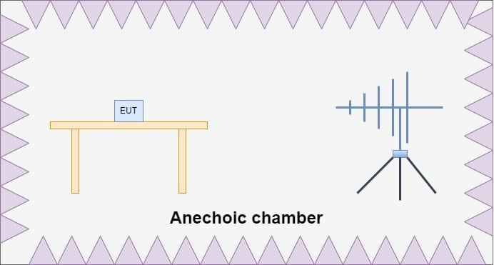
The importance of EMC testing extends beyond technical performance—it is a regulatory and commercial necessity. Regulatory bodies and international markets mandate compliance with EMC standards to prevent malfunctioning systems and to maintain interoperability among devices. For a company like Texas Instruments, rigorous EMC testing of ICs ensures that products meet global certification requirements, reduce customer field failures, and maintain brand reputation for reliability. In summary, EMC testing of ICs bridges the gap between circuit design and practical deployment by validating not only the performance of the device under ideal conditions but also its resilience in electromagnetically harsh environments. It ensures that integrated circuits remain robust, reliable, and safe when deployed in real-world applications.
Fig 2: General setup for Radiated EMC testing

4.3 Digital Isolators
Digital isolators are semiconductor devices that provide galvanic isolation between two electrical circuits while enabling high-speed digital signal transfer across the isolation barrier. Unlike traditional optocouplers that rely on LEDs and photodiodes, digital isolators use capacitive or magnetic coupling to transmit signals. This approach offers several advantages over optocouplers, including:
- Higher data rates
- Longer operational lifetimes
- Improved reliability
- Lower power consumption
As modern electronics operate at higher switching frequencies and voltages, digital isolators have become essential for ensuring safety, signal integrity, and overall system performance.
The primary importance of digital isolators lies in their ability to protect sensitive low-voltage circuits from high-voltage domains while maintaining robust communication. Key benefits include:
- Providing galvanic isolation to prevent dangerous voltage transients
- Breaking ground loops to eliminate noise propagation
- Ensuring robust signal transmission in high-EMI environments
Digital isolators are widely used in industrial automation, motor drives, medical devices, automotive electronics, isolated power supplies, and high-speed communication interfaces. Their reliability in harsh conditions makes them an indispensable component in modern system design.
Digital isolators are implemented using several key isolation technologies:
- Capacitive isolation: Transfers data across high-voltage capacitors embedded on-chip. Offers high data rates and low power consumption.
- Magnetic isolation: Uses miniature on-chip transformers to transfer signals. Provides excellent immunity to electromagnetic interference (EMI), making it ideal for industrial applications.
- Optical isolation: Relies on LEDs and photodiodes. Slower and less energy-efficient than other methods, with limited long-term reliability.
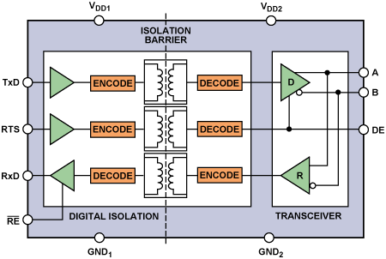
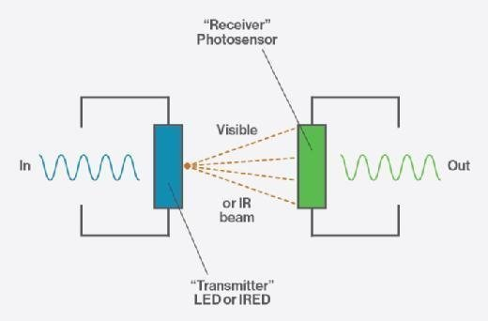
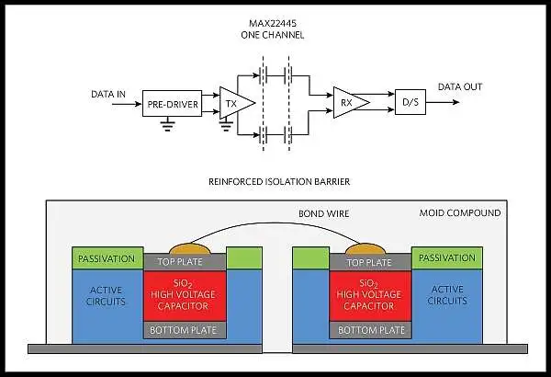
Fig 3 : Galvanic/Capacitive Isolation Fig 4 : Optical Isolation
Fig 5: Magnetic Isolation
To transmit digital information across the isolation barrier, isolators use modulation-based techniques:
- Edge-based transmission: Only signal transitions (rising and falling edges) are transmitted as short pulses.
  - Advantages: Very high-speed operation, low jitter, and low power consumption
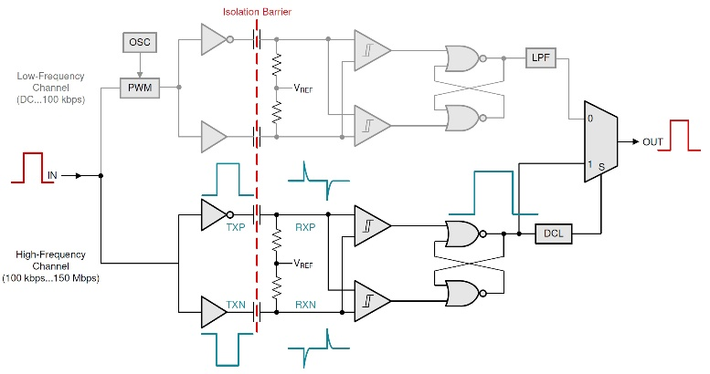
  - Consideration: Requires additional circuitry to maintain logic state during idle periods

Fig 6: Edge based communication circuit
- On-Off Keying (OOK) transmission: Encodes a digital “1” or “0” using the presence or absence of a high-frequency carrier.
  - Advantages: Simple and robust against noise
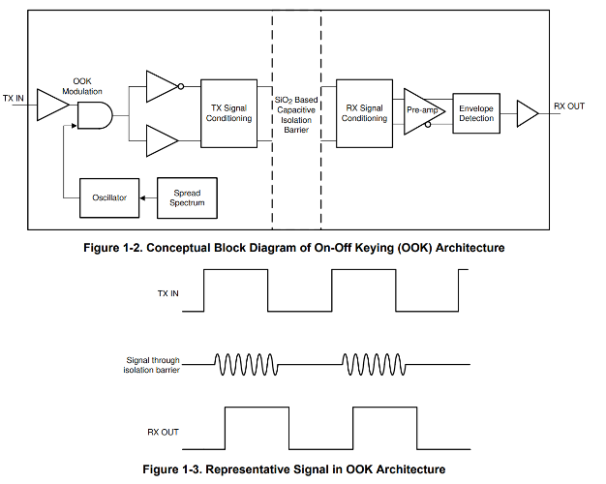
  - Consideration: Higher power consumption and lower maximum speed than edge-based transmission
Fig 7: OOK based communication circuit

In conclusion, digital isolators are critical for building safe, reliable, and high-performance electronic systems. They protect low-voltage circuits, improve signal integrity, prevent ground loops, and maintain robust operation in EMI-prone environments. Selection of the appropriate isolation technology and transmission method depends on application requirements such as speed, noise immunity, and power efficiency. As modern electronics continue to advance, digital isolators remain a vital solution for creating safe, high-speed, and EMI-resilient designs.
4.4 IEC-61000-4 (Standard for EMI testing)
IEC 61000-4 is an international standard that defines testing and measurement techniques for electromagnetic compatibility (EMC) of electrical and electronic equipment. It is part of the broader IEC 61000 series, which addresses immunity and emission requirements to ensure that devices operate reliably in environments with electromagnetic disturbances. IEC 61000-4 provides a framework for standardized testing procedures, defining the types of electromagnetic phenomena that equipment may encounter, the severity levels of exposure, and the methods to simulate these conditions in a controlled laboratory environment. By adhering to IEC 61000-4, manufacturers can ensure that their products meet global EMC requirements, reducing the risk of malfunction, data loss, or safety hazards caused by electromagnetic interference (EMI).
IEC 61000-4-3, a specific part of this standard, focuses on radiated radio-frequency (RF) electromagnetic field immunity testing. It defines methods to expose equipment under test (EUT) to controlled RF electromagnetic fields and assesses its ability to operate correctly during exposure. The standard specifies test frequency ranges, field strengths, modulation types, and exposure durations to simulate real-world RF interference conditions. Testing according to IEC 61000-4-3 is critical for devices used in environments with significant RF activity, such as industrial machinery, medical devices, automotive systems, and wireless communication equipment. By simulating these disturbances, engineers can identify vulnerabilities and implement design improvements to maintain reliable operation.
During IEC 61000-4-3 testing, the equipment is typically placed in an anechoic chamber or test environment that minimizes reflections and ensures uniform field distribution. The RF fields are applied using calibrated antennas, often with amplitude modulation to represent common interference scenarios. The device’s performance is monitored continuously to detect malfunctions, data errors, or performance degradation. Compliance with IEC 61000-4-3 ensures that the equipment can withstand radiated RF disturbances without affecting functionality, safety, or user experience. This standard is essential in achieving EMC certification and is widely referenced in regulatory approvals for consumer electronics, industrial equipment, and critical medical systems.
For digital isolators, IEC 61000-4-3 testing is particularly important because these devices are often deployed in high-EMI environments, such as industrial automation, motor drives, and medical electronics. Radiated RF fields can induce unwanted currents or spurious signals across the isolation barrier, potentially causing data corruption, signal jitter, or loss of logic state. By performing IEC 61000-4-3 testing, designers can verify the immunity of digital isolators to RF disturbances, ensuring reliable high-speed communication between isolated circuits. This testing helps in optimizing layout, shielding, and filtering strategies, ultimately improving system safety, performance, and regulatory compliance.

5)Project Description and work done

5.1 Objective of project
The objective of this internship project at Texas Instruments is to design and implement an enhanced radiated immunity (RI) test setup aimed at extending the capabilities of the existing testing infrastructure. The project focuses on increasing the data rates of the signals used during RI testing and enabling higher electromagnetic field strength levels to simulate more challenging EMI conditions. By developing this upgraded setup, the project aims to provide more rigorous and precise evaluation of device immunity, ensuring reliable characterization of performance under high-speed and high-field scenarios, and supporting the design of robust, EMI-resilient electronic systems.
5.2 Earlier testing procedure and drawbacks
The previous radiated immunity (RI) testing procedure at Texas Instruments utilized microprocessors to generate and transmit data packets in the form of ASCII characters via serial communication. These data packets were initially at lower voltage levels compatible with the microprocessor and then amplified using voltage translators to match the input requirements of the digital isolators under test. The test setup employed a loopback configuration, where data would pass through a forward channel and return via a reverse channel, allowing the microprocessor to monitor the received packets. After completing the loop, the data was down-converted to the original microprocessor voltage levels, and any bit errors or missing packets were detected. All testing was conducted inside an anechoic chamber to ensure a controlled RI field environment, simulating real-world electromagnetic interference conditions.
Despite its effectiveness in basic verification, this testing procedure had several limitations that restricted its ability to fully characterize isolator performance under demanding EMI conditions. One major drawback was the relatively low data rate of 1 Mbps, which prevented testing at the higher speeds relevant to modern high-performance applications. Additionally, the procedure was not capable of detecting short-duration glitches or transient errors that may occur in the presence of strong radiated fields, meaning subtle but critical failures could go unnoticed.
Another significant concern was the reliability of auxiliary devices, such as microprocessors and voltage translators, which were required to handle the signal generation, amplification, and monitoring. These devices could fail under high electromagnetic stress before the isolators themselves experienced any degradation, potentially masking the true performance limits of the isolators. Consequently, the existing setup did not provide a complete picture of isolator robustness, highlighting the need for an upgraded test configuration capable of higher data rates, glitch detection, and improved resilience of the supporting test hardware.
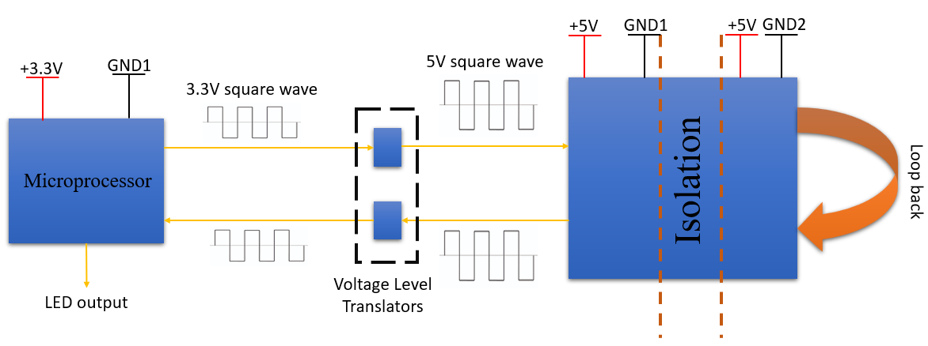
Fig. 8: Block diagram of earlier testing procedure circuit
5.3 Proposed testing procedure
The new testing system architecture for radiated immunity (RI) evaluation at Texas Instruments was designed to overcome the limitations of the previous setup and enable high-speed, continuous monitoring of digital isolators. In this updated approach, the signal generator was placed outside the anechoic chamber to ensure stable operation and protection from high electromagnetic fields. The electrical signals generated by the signal generator were converted into optical signals using an Electrical-to-Optical (E2O) converter, which allows the transmission of high-speed data through optical fibers while maintaining signal integrity and minimizing susceptibility to EMI. Once inside the chamber, the optical signals were converted back into electrical form using an Optical-to-Electrical (O2E) converter, which accurately reconstructs the original electrical signal for further processing through the device under test (DUT).
The DUT, which in this case is the digital isolator, was then subjected to the controlled RI environment within the chamber. After passing through the DUT, the resulting signals were transmitted back in a similar manner: electrical signals were first converted to optical signals using an E2O converter, sent through optical fibers, and then converted back to electrical form using an O2E converter. This bidirectional conversion ensured that the high-speed data could traverse the isolators and chamber environment without degradation caused by electromagnetic interference. Finally, the output signals were observed on an oscilloscope located outside the chamber, allowing precise measurement and monitoring without exposing sensitive instruments to high-field conditions.
A major improvement in the testing procedure was the shift from packet-based transmission to continuous data transmission. Instead of sending discrete data packets and monitoring for missing bits, the system now continuously transmits a high-speed data stream through the DUT. The oscilloscope continuously observes this data stream, capturing all rising and falling edges, pulse widths, and timing information in real time. This setup allows the detection of transient faults such as glitches, bit misses, or the creation of spurious bits, which were difficult to capture in the earlier packet-based system. Continuous observation significantly enhances the ability to identify subtle failures under high-field RI conditions.
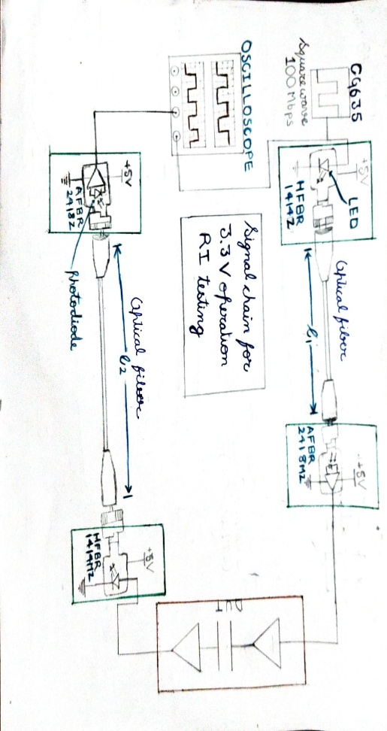
Additionally, the oscilloscope and signal generator were configured with trigger settings to detect faults based on rising edge, falling edge, and pulse width parameters. By setting precise thresholds for these triggers, the system can automatically capture anomalies and provide detailed analysis of isolator behaviour under radiated fields. This approach ensures that even short-duration glitches, which may not result in complete bit loss but could affect system reliability, are recorded and analysed. The combination of optical isolation, continuous high-speed transmission, and edge/pulse-width monitoring provides a robust framework for accurately characterizing the performance and resilience of digital isolators in high-EMI environments.

Fig. 9: Block Diagram of new testing architecture
5.4 Components used in new testing architecture
- Signal/Function Generator
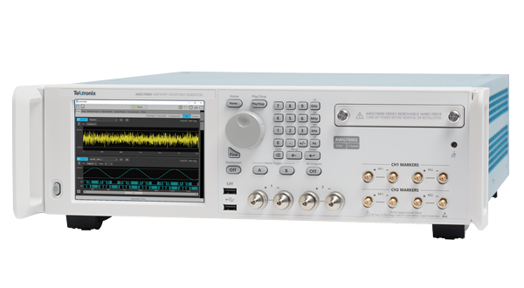
The signal generator is an electronic test instrument used to produce precise electrical waveforms over a wide range of frequencies and amplitudes. In this project, it generates high-speed digital signals that are used to test the performance of digital isolators. The generator is capable of producing continuous data streams with controlled rise/fall times and pulse widths. The generated signals serve as the input for the E2O converter, enabling accurate transmission through the optical testing setup.
Fig. 10: Signal Generator

- Optical to Electrical converter
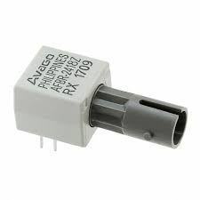
The Optical-to-Electrical (O2E) converter is a device that converts optical signals carried by fiber optics back into electrical signals. In this testing setup, it receives high-speed optical data transmitted through the chamber and reconstructs the original electrical waveform for the DUT. The O2E converter ensures signal integrity and minimizes errors caused by electromagnetic interference. It enables accurate measurement and analysis of digital isolator performance under high-field conditions. By converting optical signals back to electrical form, it allows the oscilloscope and other instruments outside the chamber to monitor the test results safely.
Fig. 11: O2E converter (AFBR-2418)

- Electrical to Optical converter
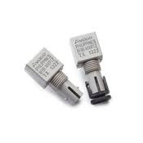
The Electrical-to-Optical (E2O) converter is a device that transforms electrical signals into optical signals for transmission through fiber optic cables. In this testing setup, it converts high-speed digital signals from the signal generator into optical form to ensure immunity from electromagnetic interference. The E2O converter preserves the integrity of the original waveform while enabling long-distance or high-field transmission inside the anechoic chamber. It plays a critical role in the test setup by allowing signals to safely pass through the RI environment without distortion. By interfacing with O2E converters at the receiving end, it ensures accurate bidirectional communication for evaluating the DUT.
Fig. 12 E2O converter (HFBR-1414)

- Power Amplifier
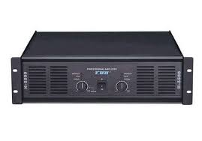
The power amplifier is used to amplify signals to generate the required electromagnetic field strength inside the anechoic chamber for radiated immunity (RI) testing. It takes the input from the signal generator and increases its power to create a strong, controlled RI environment around the DUT. The amplifier ensures that the field levels are sufficient to simulate real-world electromagnetic interference conditions. It maintains signal integrity while providing consistent field strength across the test area. By enabling precise control of the RI environment, the power amplifier is essential for accurate and reliable immunity testing of digital isolators.
Fig. 13 Power Amplifier

- Horn antenna

The horn antenna is used to emit radiated electromagnetic fields and create a controlled RI environment inside the anechoic chamber. It converts the amplified signals from the power amplifier into uniform radiated fields that interact with the DUT. The antenna’s design ensures a predictable and stable field distribution, minimizing reflections and hotspots. It allows accurate simulation of real-world electromagnetic interference conditions for testing purposes. By providing reliable field emission, the horn antenna is a critical component for evaluating the immunity of digital isolators.
Fig. 14: Horn Antenna

- Electromagnetic Field Probe
The electromagnetic (EM) field probe is used to measure and monitor the strength and uniformity of radiated fields inside the anechoic chamber. It provides real-time feedback on the electromagnetic environment to ensure the desired field levels are achieved for testing. The probe helps verify that the DUT is exposed to consistent and accurate RI conditions. It is sensitive to a wide range of frequencies, making it suitable for high-speed digital isolator testing. By enabling precise field measurements, the EM field probe is essential for validating and calibrating the RI test setup.
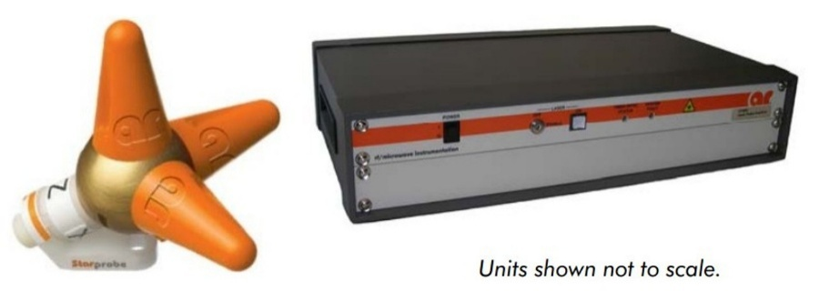
Fig. 15: Electromagnetic Field Probe
- Oscilloscope
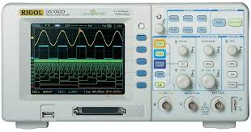
The oscilloscope is used to monitor and visualize high-speed signals during RI testing of digital isolators. It captures continuous data streams, displaying voltage levels, timing, and waveform integrity in real time. Trigger settings are configured to detect anomalies such as glitches, bit misses, or pulse-width errors. Placed outside the anechoic chamber, it allows safe observation without exposure to high electromagnetic fields. By providing precise signal analysis, the oscilloscope is essential for identifying faults and validating DUT performance.
Fig. 16: Oscilloscope
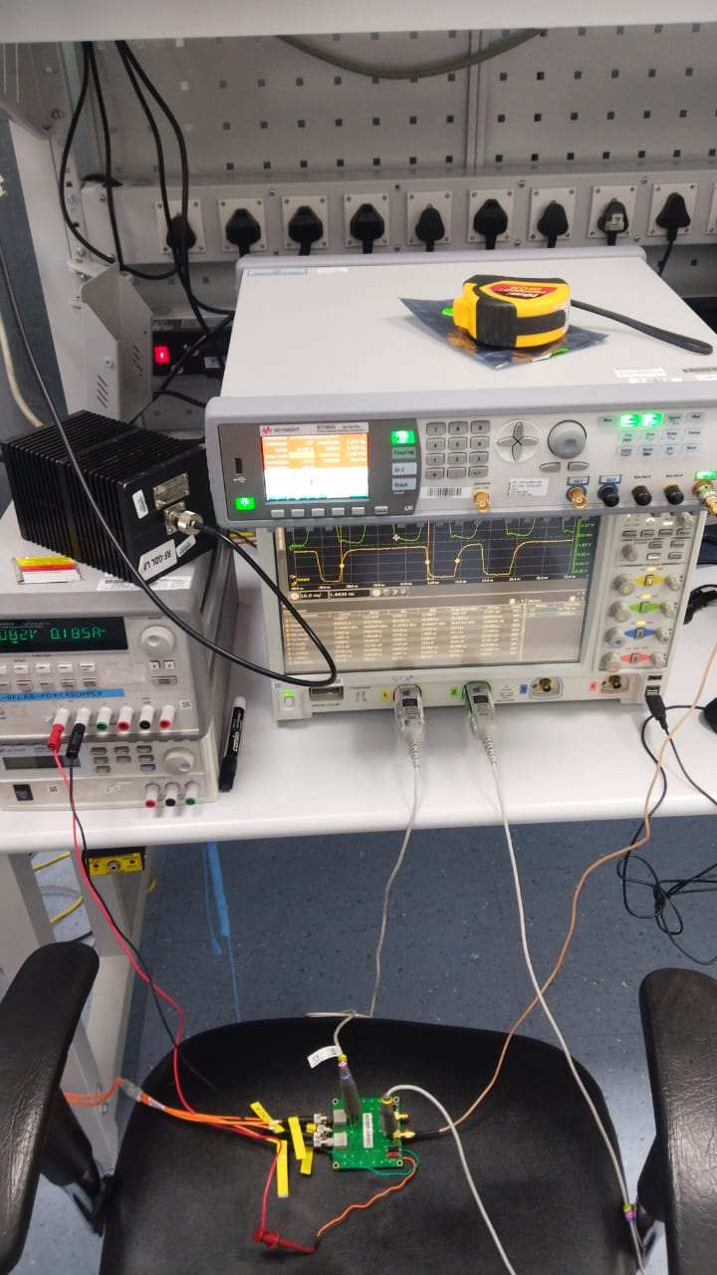
5.5 Test Setup Images
Fig 17: Setup outside the chamber

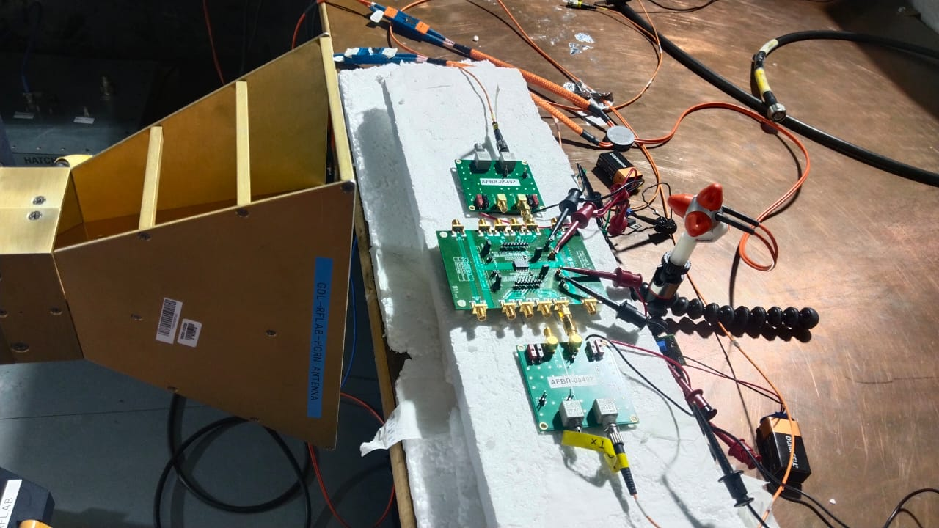
Fig. 18: Setup inside the chamber

6)Challenges and Further Improvements
6.1 Challenges Faced
One of the primary challenges faced during the project was the limitations of the existing RI testing setup. The earlier procedure, which relied on microprocessors for packet-based data transmission, operated at a low data rate of 1 Mbps and lacked the capability to detect transient faults or glitches. This made it difficult to accurately evaluate high-speed digital isolators under realistic EMI conditions. Additionally, auxiliary devices such as voltage translators and microprocessors could fail before the isolators themselves, potentially masking the true performance limits of the DUT. Overcoming these limitations required redesigning the system to support continuous high-speed data transmission while maintaining signal integrity across the isolation barrier.
Another significant challenge was managing signal integrity, EMI issues, and timing skew within the test setup. Converting electrical signals to optical signals and back (using E2O and O2E converters) for transmission inside the anechoic chamber introduced potential sources of distortion, including pulse shape changes, timing jitter, and signal attenuation. A particular difficulty was monitoring and compensating for timing skew between the input and output of the signal chain, which made it harder to analyze the root cause of faults accurately. Ensuring that the transmitted signals faithfully represented the original waveform, especially at higher data rates, required careful calibration of the converters, power amplifiers, and field-emitting components. Precise alignment of optical fibers and verification of bidirectional transmission further added to the complexity of the setup.
A third challenge involved developing a reliable, real-time monitoring mechanism for detecting faults such as glitches, bit misses, and spurious bit creation. Switching from packet-based transmission to continuous data streams necessitated configuring oscilloscopes with accurate trigger settings for rising/falling edges and pulse widths. The presence of timing skew required additional analysis and adjustments to distinguish whether anomalies were caused by the DUT or by delays introduced in the signal path. Ensuring that all anomalies could be captured and analyzed in real time demanded repeated iterations of the setup, along with meticulous synchronization between the signal generator, converters, and measurement instruments. Balancing high-speed operation, EMI resilience, and accurate data capture demanded both technical expertise and iterative troubleshooting, making the project both challenging and highly instructive.
6.2 Benefits of the setup
The newly developed RI testing setup offers a significant increase in bandwidth compared to the previous microprocessor-based system. By incorporating optical transmission using E2O and O2E converters and leveraging high-speed continuous data streams, the setup can handle much faster signal rates, closely matching the operating speeds of modern digital isolators. This greater bandwidth enables the detection of subtle transient faults and ensures that the DUT can be thoroughly evaluated under realistic high-frequency electromagnetic disturbances. As a result, the setup provides a more accurate representation of device performance under challenging RI conditions, which is critical for designing robust ICs.
Another major advantage is the ability to perform real-time monitoring and analysis of transmitted signals. Continuous observation of the data stream on an oscilloscope with precise trigger settings for rising and falling edges, as well as pulse width, allows the detection of glitches, bit misses, and spurious bit creation as they occur. This real-time capability eliminates the delays and uncertainties associated with packet-based post-analysis, enabling engineers to immediately identify abnormal behavior. The high-speed monitoring ensures that even short-duration anomalies, which could impact system reliability, are captured and recorded for further investigation.
The developed setup also provides greater overall system robustness. By using optical transmission to isolate the signal chain from high electromagnetic fields, the system minimizes susceptibility to interference, ground loops, and auxiliary device failures. The use of continuous high-speed data, along with improved signal fidelity and bidirectional verification, ensures that the DUT is tested under consistent and repeatable conditions. This robustness makes the test results more reliable and meaningful, allowing for confident evaluation of isolator performance in high-EMI environments.
Finally, the setup greatly facilitates the identification of root causes of failure, which is essential for IC design correction. The combination of high-speed continuous transmission, optical isolation, and precise timing monitoring allows engineers to determine whether observed faults are due to DUT limitations, signal distortion, or timing skew in the test chain. By accurately pinpointing the source of errors, designers can make informed modifications to improve the reliability, performance, and EMI resilience of the IC. This targeted approach significantly reduces iterative design cycles and accelerates the development of robust, high-performance digital isolators.
6.3 Scope of Further Improvements in setup

One potential improvement to the existing RI testing setup is the integration of a Picoscope with inbuilt function/signal generator or an FPGA development board. By replacing multiple discrete instruments with these versatile devices, the test setup can be made more compact and less bulky. A Picoscope with a built-in generator can simultaneously generate high-speed signals and capture the DUT output, while an FPGA board can provide highly customizable digital signal generation and monitoring. This integration reduces cabling, power consumption, and the overall footprint of the setup, enabling easier deployment and handling while maintaining high test performance.
Another significant improvement is the programming and automation of the testing process. Automating the procedure allows precise control over test parameters such as pulse width, edge timing, and repetition rates, which helps mitigate issues like pulse shape distortion caused by manual adjustments or external circuitry. Furthermore, automation facilitates continuous monitoring and logging of test results, enabling the precise identification of failure modes such as bit misses, glitches, or pulse distortion. This ensures that faults can be traced directly to the DUT rather than being influenced by inconsistencies in the test setup.
The use of laser-based optical-to-electrical (O2E) converters offers a further enhancement by providing significantly greater bandwidth for high-speed signal transmission. Compared to conventional O2E converters, laser-based devices can handle faster data rates with minimal signal degradation, allowing the testing of digital isolators at higher speeds and with improved fidelity. This higher bandwidth capability ensures that subtle transient faults, which may occur only at elevated frequencies, can be accurately captured and analyzed, increasing the reliability and comprehensiveness of RI testing.
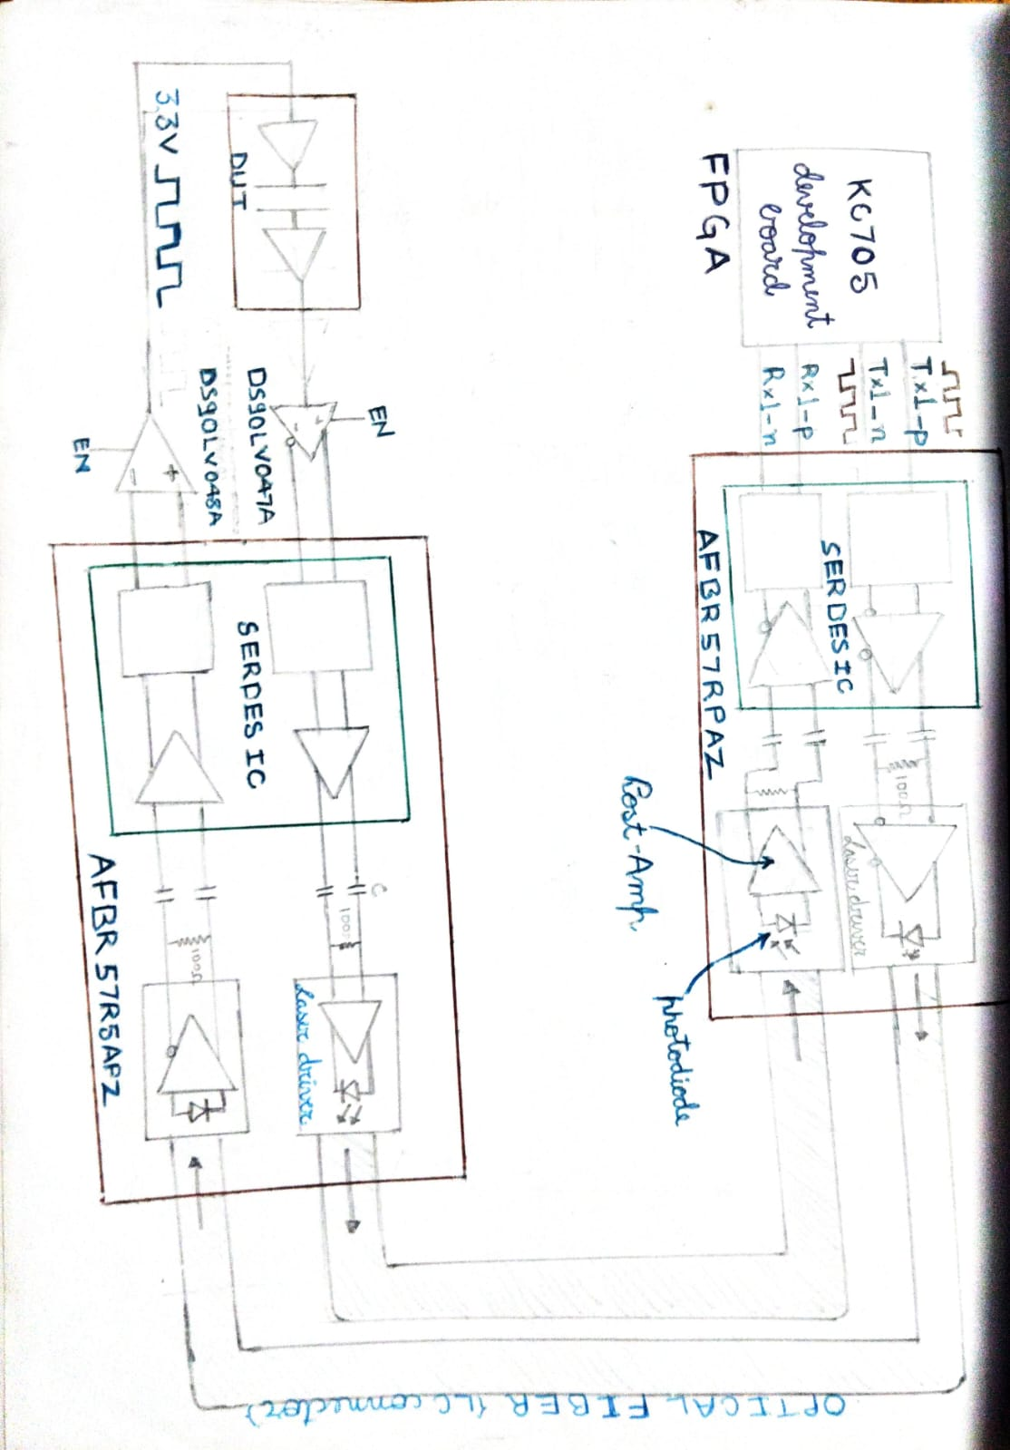
Finally, implementing Low Voltage Differential Signaling (LVDS) techniques in the test setup can improve the robustness and reliability of measurement results. LVDS uses differential signal transmission, which reduces susceptibility to electromagnetic interference and minimizes ground loop effects. By employing LVDS for both forward and reverse channels, the test setup can maintain signal integrity even in high-field RI environments, ensuring that errors detected are truly representative of DUT performance. This technique enhances the accuracy of measurements and strengthens confidence in the evaluation of isolator immunity under extreme EMI conditions.
Fig. 19: Block diagram of testing architecture with further improvements

7) Conclusion
The internship project at Texas Instruments provided me with valuable exposure to the field of radiated immunity (RI) testing and its role in evaluating the robustness of digital isolators. Through this work, I was able to analyze the limitations of the existing microprocessor-based test procedure and contribute to the development of an improved testing setup that offered higher bandwidth, continuous data monitoring, and greater fault detection capabilities. By integrating optical transmission, high-speed signal handling, and real-time analysis tools, the new setup not only enhanced testing accuracy but also made the process more reliable and efficient.
This project also helped me gain practical insights into challenges such as maintaining signal integrity, mitigating timing skew, and ensuring accurate fault identification in high EMI environments. Overcoming these challenges strengthened my technical problem-solving skills and deepened my understanding of both circuit design and testing methodologies. Overall, the project has not only expanded my technical knowledge but also emphasized the importance of systematic validation in IC design, providing me with valuable learnings that will support my growth as an engineer.

